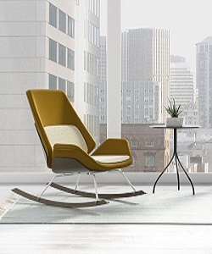Age-old Rocking Chair

$16.33

Availability: In stock

### Description

Modern yellow age-old design of the rocking chair. This chair is reimagining the age-old design of the rocking chair by infusing the classic piece of furniture with comfortable materials and a modernist look. This sleek and contemporary chair features an upholstered seat complete with wooden accents, producing a capsule piece of furniture that stays true to its roots. The chair rests on solid wood rockers and is connected by a tubed base. The outer seat is comprised of a solid wood, while the inner seat and cushioning are individually selected, allowing for complete customization.